**SCO project WEB sheet – 2025 Edition**

Document to be completed and returned to [sco_secretariat@cnes.fr](mailto:sco_secretariat@cnes.fr)

All SCO-labelled projects will eventually be visible on the website www.spaceobservatory.org. The description of the project on the SCO website is a free text with no length limitation (except for the summary). HTML links are possible, as well as images (png, jpg, tiff, gif) or YouTube videos. Documents, images and videos can also be attached as resources.

The mapping of the website allows to position a project on different territories of experimentation, which will eventually allow to valorize local results in a specific way. However, for the sake of consistency, the following fields must be filled in.

**Recommendations:**

* **Use a short project name to facilitate communication.**
* **Use short sentences.**
* **Avoiding overly focused or technical jargon.**
* **Put key information in bold.**
* **If long text or a lot of information to be indicated, partition with subtitles.**

# Project acronym:

# Developed title of the project

# Duration (in months)

# Budget

**...** k€

Main image (displayed on the right of the project description)  
Limited to 500 Kb  
Allowed types: png gif jpg jpeg  
Images must be larger than the following dimensions: **400x350** pixels

Where possible, please provide image files that offer better quality than an extraction from a Word document.

**Caption:**

**Copyright: ©**

# Summary/Introduction (maximum 400 characters including spaces)

# Overview

NB: Images (specifying caption and copyright ©) and other material can be included.

# Application site(s)

Territory 1: name, country + mandatory GPS coordinates in decimal format [latitude,longitude].

Territory 2: name, country + mandatory GPS coordinates in decimal format [latitude,longitude].

...

# Data

**Satellite**

**Other**

# Results - Final product(s)

# References (optional)

Scientific publication(s) as reference and associated web link(s)

# Related project(s) (optional)

# Resources (optional)

All types of documents to be uploaded (doc, pdf, xls, video...) => please list here the names of the files to be uploaded

# Project partners (starting with the project manager)

**Partner 1**

Name:

Website (http://www.....):

Logo (size > 200x200 pixels REQUIRED)

**Partner 2**

Name:

Website (http://www.....):

Logo (size > 200x200 pixels REQUIRED)

**...**

# Contact form e-mails with separator (,)

Starting with the project driver(s)

Example: First nam NAME : ...@cnes.fr (or @snsa.se, @ario.sk etc.)

|  |  |
| --- | --- |
| **NB: unless you indicate otherwise, the name and e-mail address of the pilot(s) will be the contact details given in the “**[**SCO Portfolio**](https://www.spaceclimateobservatory.org/new-look-sco-portfolio)**” publication.**Updated every year, this booklet lists all the projects that have been accredited with the SCO label, with a maximum of 3 privileged contacts for each one, to encourage links and synergies within the SCO community. | Agreed, use the first / 2 / 3 contact(s) above (cross out or delete as appropriate)  No agreement, indicate in the SCO Portfolio the following contact(s): (3 max)  … |

**⚠️ *Please inform us of any change of person or email in the contacts on the webpage and in the SCO Portfolio.***

# Thematic categorization of the project (several choices possible):

|  |  |
| --- | --- |
| **Themes**  Agriculture (crops)  Biodiversity  Carbon (CO2)  Education  Energy  Extreme weather  Forest fires  Health  Land use  Response to natural disasters  Vegetation  Water management | **Environments**  Atmosphere  Coastlines  Forests  Mountains  Ocean  Rural area  Tropical environment  Urban environment |

* **Priority theme (mandatory): …..**
* **Secondary theme (optional): …..**

# Categorization of the project's sustainable development objectives (several choices possible):

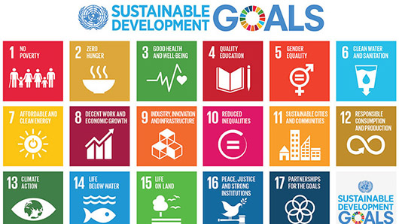

1. Fighting poverty

2. Fighting hunger

3. Access to health

4. Access to quality education

5. Gender equality

6. Access to safe water and sanitation.

7. Use of renewable energy

8. Access to decent jobs

9. Build resilient infrastructure, promote sustainable industrialisation that benefits all and foster innovation

10. Reducing inequalities

11. Sustainable cities and communities

12. Responsible consumption and production

13. Combating climate change

14. Aquatic life

15. Life on earth

16. Justice and peace

17. Partnerships for the achievement of objectives

**You have reached the end, THANK YOU!**

As soon as we receive this document, we will read it again and, if necessary, propose some adaptations to ensure the harmony of the different project pages.

As the website is bilingual, we will translate this sheet into French. If you wish, you can submit your translation directly to us. Please feel free to provide the visuals and any resources in both languages.